Module 4 Portfolio Project

Alex Zelmanowicz

Colorado State University Global

Professor Farr

CSC 500

10 March 2024

**Step 1:**

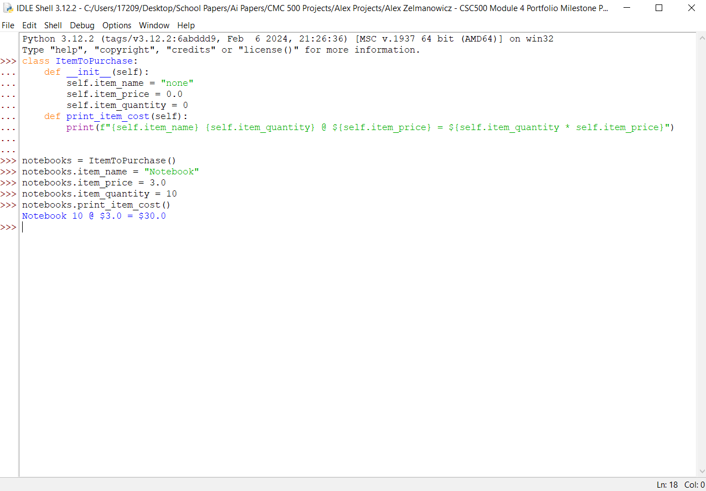

**Step 2:**

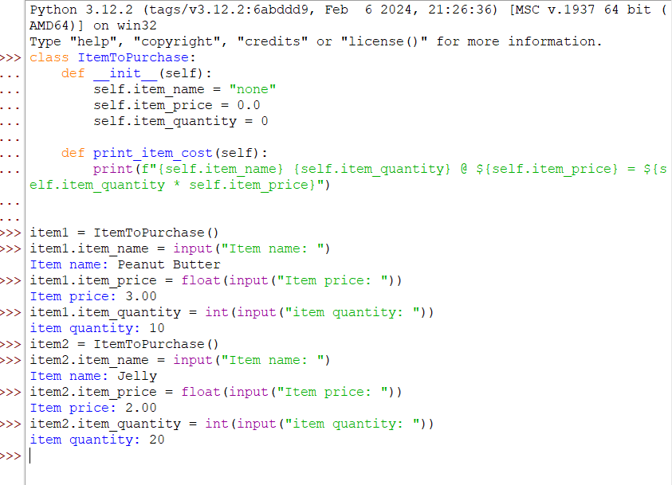

**Step 3:**

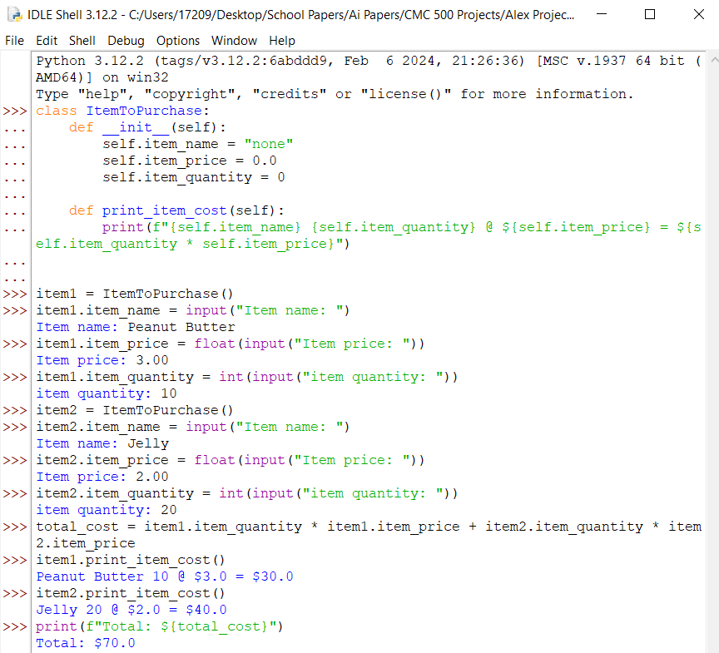

**Step 1 Source Code:**

>>> class ItemToPurchase:

... def __init__(self):

... self.item_name = "none"

... self.item_price = 0.0

... self.item_quantity = 0

... def print_item_cost(self):

... print(f"{self.item_name} {self.item_quantity} @ ${self.item_price} = ${self.item_quantity * self.item_price}")

...

...

>>> notebooks = ItemToPurchase()

>>> notebooks.item_name = "Notebook"

>>> notebooks.item_price = 3.0

>>> notebooks.item_quantity = 10

>>> notebooks.print_item_cost()

Notebook 10 @ $3.0 = $30.0 **Step 2 Source Code:**

>>> class ItemToPurchase:

... def __init__(self):

... self.item_name = "none"

... self.item_price = 0.0

... self.item_quantity = 0

...

... def print_item_cost(self):

... print(f"{self.item_name} {self.item_quantity} @ ${self.item_price} = ${self.item_quantity * self.item_price}")

...

...

>>> item1 = ItemToPurchase()

>>> item1.item_name = input("Item name: ")

Item name: Peanut Butter

>>> item1.item_price = float(input("Item price: "))

Item price: 3.00

>>> item1.item_quantity = int(input("item quantity: "))

item quantity: 10

>>> item2 = ItemToPurchase()

>>> item2.item_name = input("Item name: ")

Item name: Jelly

>>> item2.item_price = float(input("Item price: "))

Item price: 2.00

>>> item2.item_quantity = int(input("item quantity: "))

item quantity: 20

**Step 3 Source Code:**

>>> class ItemToPurchase:

... def __init__(self):

... self.item_name = "none"

... self.item_price = 0.0

... self.item_quantity = 0

...

... def print_item_cost(self):

... print(f"{self.item_name} {self.item_quantity} @ ${self.item_price} = ${self.item_quantity * self.item_price}")

...

...

>>> item1 = ItemToPurchase()

>>> item1.item_name = input("Item name: ")

Item name: Peanut Butter

>>> item1.item_price = float(input("Item price: "))

Item price: 3.00

>>> item1.item_quantity = int(input("item quantity: "))

item quantity: 10

>>> item2 = ItemToPurchase()

>>> item2.item_name = input("Item name: ")

Item name: Jelly

>>> item2.item_price = float(input("Item price: "))

Item price: 2.00

>>> item2.item_quantity = int(input("item quantity: "))

item quantity: 20

>>> total_cost = item1.item_quantity * item1.item_price + item2.item_quantity * item2.item_price

>>> item1.print_item_cost()

Peanut Butter 10 @ $3.0 = $30.0

>>> item2.print_item_cost()

Jelly 20 @ $2.0 = $40.0

>>> print(f"Total: ${total_cost}")

Total: $70.0

**Pseudocode:**1. Start.

2. Make a class called ItemToPurchase.

3. Input item_name as "none", item_price as 0.0, and item_quantity as 0.

4. Make a method named print_item_cost.

5. Make an instance of ItemToPurchase called item1.

6. Ask the user for the name, price, and quantity of item1.

7. Make a second instance of ItemToPurchase called item2.

8. Ask the user for the name, price, and quantity of item2.

9. Calculate the cost of item 1 by its quantity multiplied by price.

10. Calculate the cost of item 1 by its quantity multiplied by price.

11. Print the details for item 1 and item 2.

12. find the total cost by adding both total prices of item 1 and item 2 by all its quantity.

13. print the total cost of all items.

14. End.

**Git Repository**: https://github.com/AlexCSUGlobal/CSC500